NOTE: THIS DOCUMENT IS INTENDED TO BE USED AS A TEMPLATE. THIS DOCUMENT CONTANS BRACKETS [] WITH SUGGESTIONS FOR WHAT INFORMATION TO INCLUDE IN THOSE SECTIONS. ALL CAMPAIGN RESOURCES AND LINKS IN THIS EMAIL CAN BE EDITED TO YOUR SPECIFIC CAMPAIGN. ALL AVAILABLE RESOURCES ARE NOT LINKED IN THIS DOCUMENT. PLEASE INSERT RESOURCES YOU WISH TO USE FOR YOUR CAMPAIGN. RESOURCE LINKS MUST BE UPDATED WITH LINKS TO APPROPRIATE LANGUAGE AND STATE-SPECIFIC RESOURCES.

PRINT MEDIA TOOLKIT:
POSTERS, FACT SHEETS, COMICS, AND STICKERS

Hello! This document contains links to all printable materials to support the [INSERT NAME OF CAMPAIGN] campaign. These resources are in [INSERT LANGUAGE OF CAMPAIGN. EXAMPLE: SPANISH] and this toolkit contains English translations for the materials. Please click the included links to download the image files onto your computer.

[INSERT REMINDER OF PRINT-RELATED CAMPAIGN ASK. EXAMPLE: AS A REMINDER, WE ASK THAT YOU PRINT A MINIMUM OF ONE OF THESE RESOURCES IF YOUR ORGANIZATION APPROVES. FEEL FREE TO PRINT MORE AND TO KEEP A RECORD OF THE RESOURCES YOU DISTRIBUTE.]
POSTER LINKS

About: This resource can be used printed for your organization building or for other locations. Please feel free to use the poster image files for other purposes. Each poster includes editable sections for community-specific vaccine sign-up phone numbers and website links. Feel free to add you organization logo.

To Download: To download please click the link for the image you wish to download below. Right click image, click ‘save image as’, and save to desired folder on your computer.

To Edit: All posters are editable with Adobe Acrobat. Once document is opened with Adobe Acrobat click 'Edit' and scroll to the bottom of the document. Additionally, logos can be added.

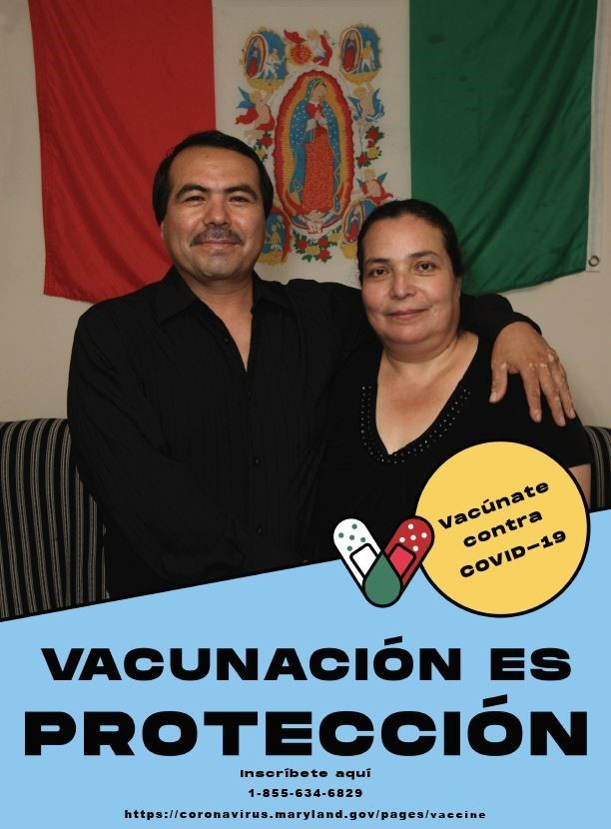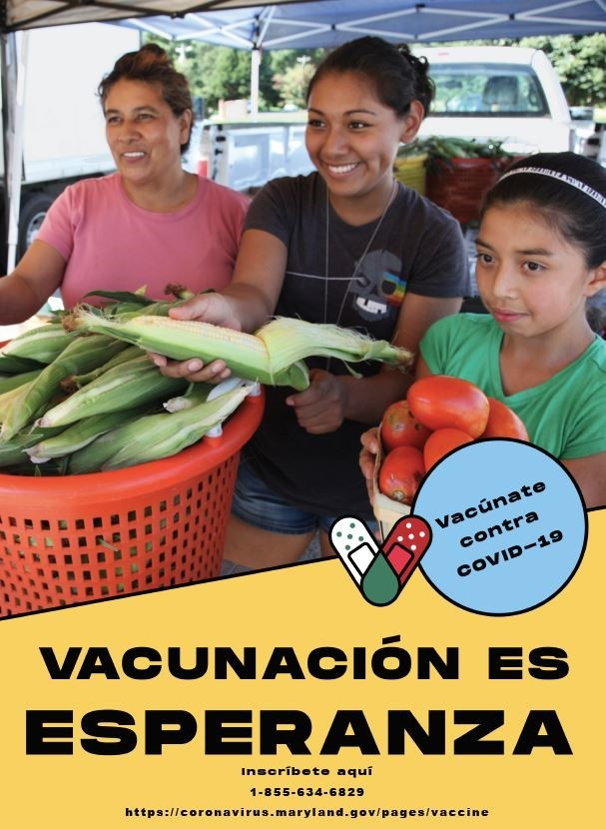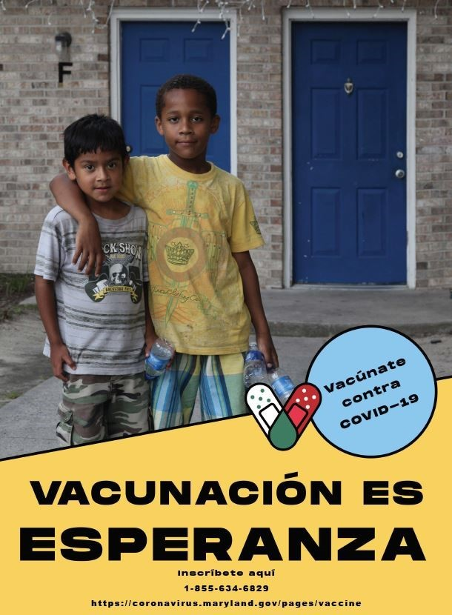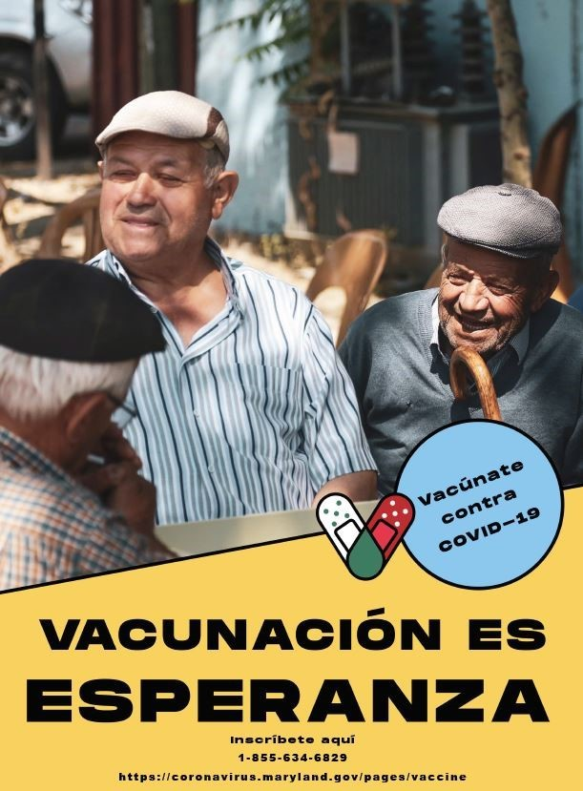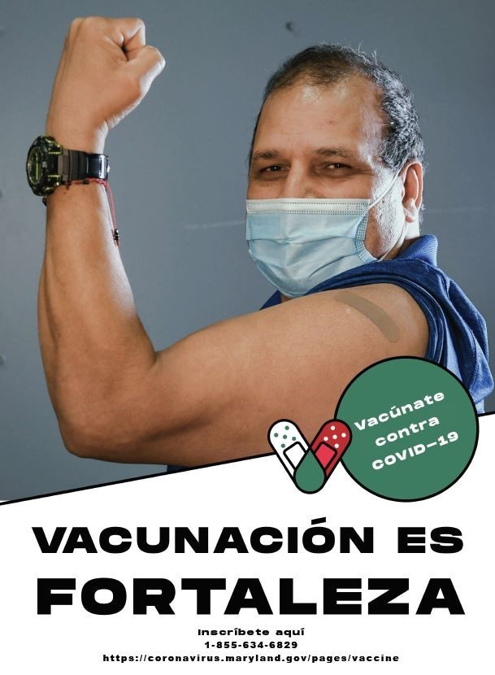

Links:

- Vacunación Es Protección - Hombre y Mujer
- Vacunación Es Esperanza – Mujeres y niñas
- Vacunación Es Esperanza – Niños
- Vacunación Es Esperanza – Hombres de Tercera Edad o Ancianos
- Vacunación Es Fortaleza – Hombre Enseñando Músculo

English Translation of the Above Links:

- Vaccination is Protection (Blue) – Man and Woman
- Vaccination is Hope (Gold) – Woman and Girls
- Vaccination is Hope (Gold) – Boys
- Vaccination is Hope (Gold) – Elderly Men
- Vaccination is Strength (White) – Man Making Muscle

FACT SHEET LINKS

About: These pre-made fact sheets can be printed as fliers or posters. However, please feel free to use them for other purposes. Each resource contains English translations.

To Download: To download click the download link When resource page opens, right click image and select 'Save Image As' to download to the appropriate folder on your computer.

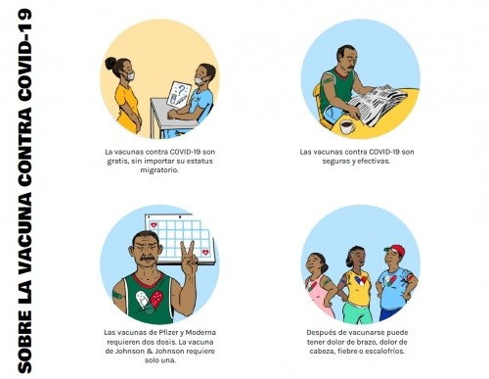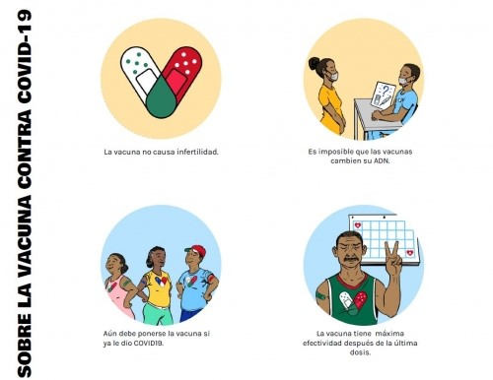

Link:

- Hoja Informativa #1: Sobre La Vacuna Del COVID-19
- Hoja Informativa #2: Sobre La Vacuna Del COVID-19

English Translation of the Above Links:

- Fact Sheet #1: About the COVID-19 Vaccine
- Fact Sheet #2: About the COVID-19 Vaccine

COMIC LINKS

About: These pre-made comics can be printed as fliers or posters. However, please feel free to use them for other purposes. Each resource contains English translations.

To Download: To download click the download link When resource page opens, right click image and select 'Save Image As' to download to the appropriate folder on your computer.

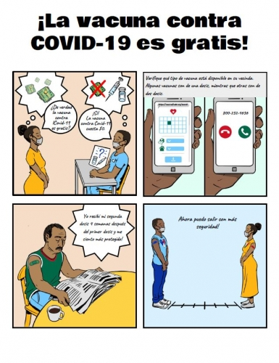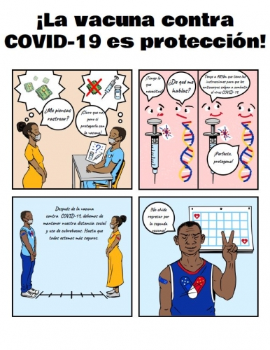

Link:

- ¡La Vacuna contra el COVID-19 es gratis! - Cómic
- ¡La vacuna contra el COVID-19 es protección! - Cómic

English Translation of the Above Links:

- The COVID-19 Vaccine is Free! - Comic
- The COVID-19 Vaccine Is Protection! - Comic

STICKERS

About: These pre-made images can be printed as stickers or even used as social media images. Please feel free to use them for other purposes. They include a band-aid symbol in colors that correspond with country flags in Latin American countries. They are meant to support both vaccine advocacy and community pride.

To Download: To download click the download link. A MCN webpage will open. Click desired image link. The image will open in a new window. Right click the image and select ‘save image as’ and save to your desired folder.

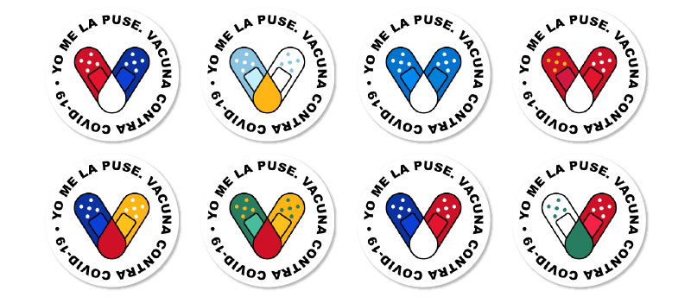

Link:

- Yo Me La Puse – Vacuna Contra El COVID-19 – Calcomanía

English Translation of the Above Link:

- I got vaccinated - The COVID-19 vaccine – V-Mark Sticker

