Words Matter: The Impact of Anti-Immigrant Rhetoric and Policies on Clinicians and Patients: A 3-Part Webinar Series
Resources
Webinar 1: Words and Policies Do Harm: Supporting Clinicians Serving Immigrants
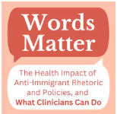 | Words Matter: The Health Impact of Anti-Immigrant Rhetoric and Policies, and What Clinicians Can Do  Link: https://www.migrantclinician.org/blog/2024/jun/words-matter-health-impact-anti-immigrant-rhetoric-and-policies-and-what-clinicians
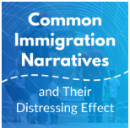 | Common Immigration Narratives and Their Distressing Effect  Link: https://www.migrantclinician.org/blog/2024/may/common-immigration-narratives-and-their-distressing-effect.html
 | Are There Health Consequences to An Anti-Immigrant Climate for Undocumented Immigrants?  Link: https://www.migrantclinician.org/blog/2024/aug/are-there-health-consequences-anti-immigrant-climate-undocumented-immigrants.html
 | Words Matter: The Impact of Anti-Immigrant Rhetoric and Policies Videos  Link: https://www.youtube.com/watch?v=dbacuzljBJ8&list
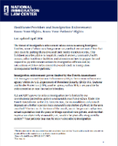 | Health Care Providers and Immigration Enforcement: Know Your Rights, Know Your Patients’ Rights  Link: https://www.nilc.org/resources/healthcare-provider-and-patients-rights-imm-enf/
Webinar 2: Practices that Heal: Working with Latinx Immigrants Who Suffer Multiple Adversities
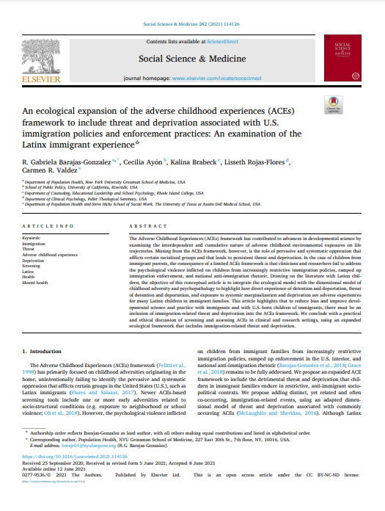 | An ecological expansion of the adverse childhood experiences (ACEs) framework to include threat and deprivation associated with U.S. immigration policies and enforcement practices: An examination of the Latinx immigrant experience  Link: https://www.sciencedirect.com/science/article/pii/S0277953621004585
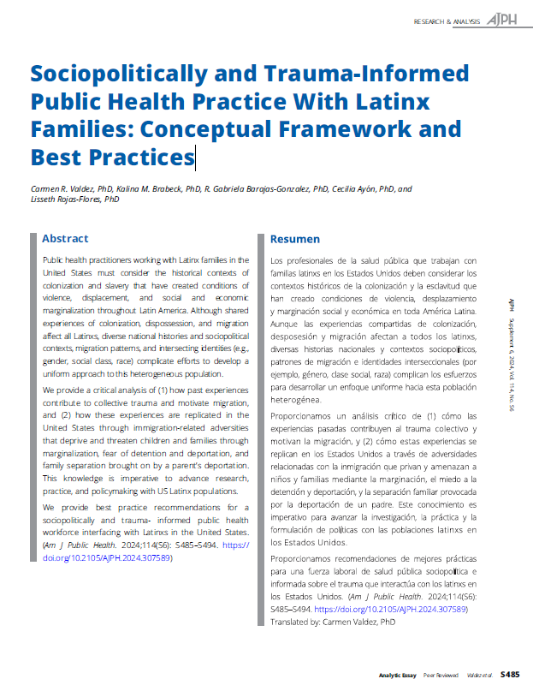 | Sociopolitically and Trauma-Informed Public Health Practice with Latinx Families: Conceptual Framework and Best Practices  Link: https://ajph.aphapublications.org/doi/epdf/10.2105/AJPH.2024.307589
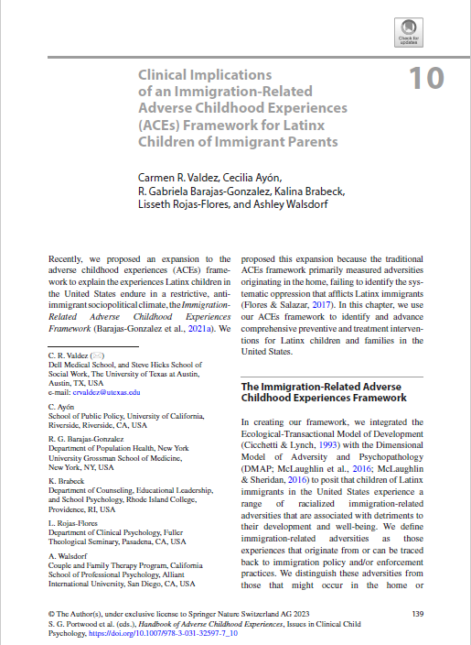 | Clinical Implications of an Immigration-Related Adverse Childhood Experiences (ACEs) Framework for Latinx Children of Immigrant Parents
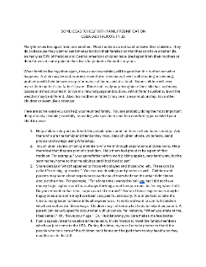 | Some Ideas to Help with Family Reunification

Webinar 3: Post-Election Advocacy and Activism for Clinicians Serving Immigrant and Migrant Patients
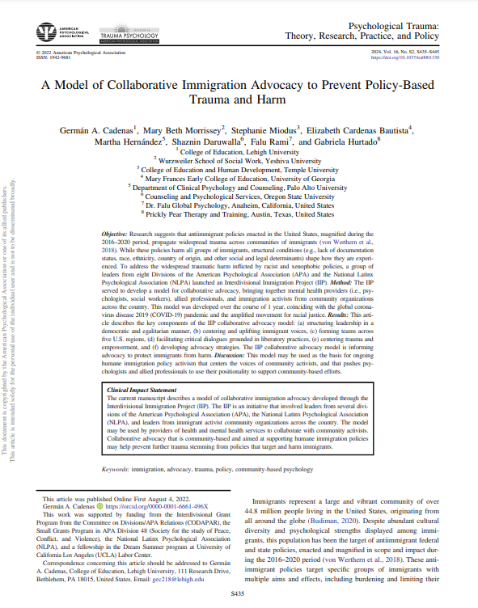 | A Model of Collaborative Immigration Advocacy to Prevent Policy-Based Trauma and Harm  Link: https://psycnet-apa-org.libproxy2.usc.edu/fulltext/2022-86691-001.pdf
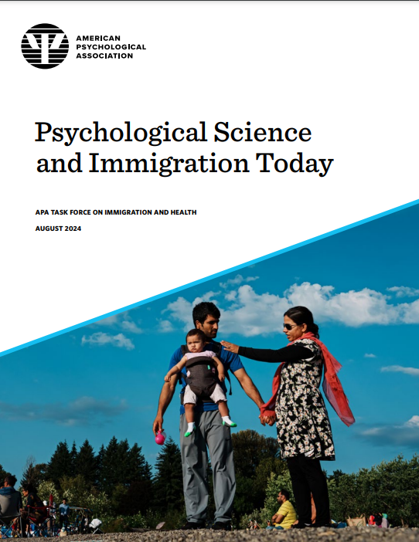 | Psychological Science and Immigration Today  Link: https://www.apa.org/pubs/reports/psychological-science-immigration-today.pdf
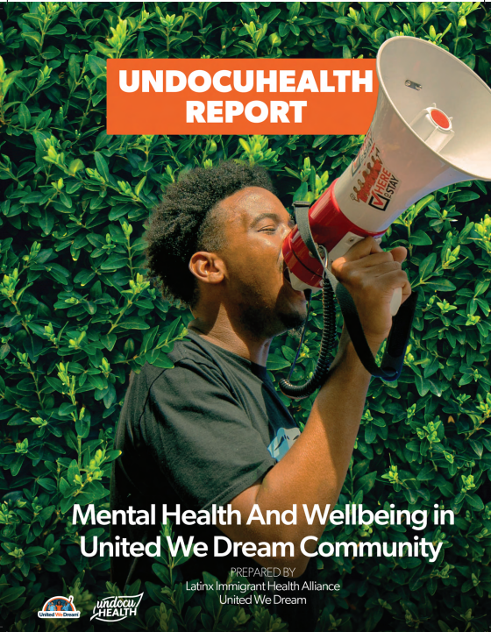 | Undocuhealth Report: Mental Health and Wellbeing in United We Dream Community  Link: https://unitedwedream.org/resources/2021-undocuhealth-report/
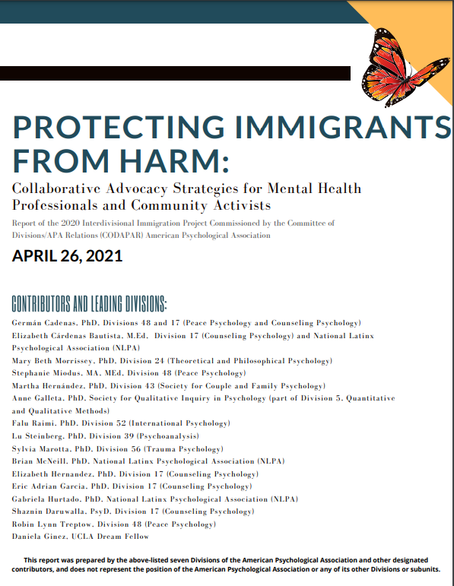 | Protecting Immigrants from Harm: Collaborative Advocacy Strategies for Mental Health Professionals and Community Activists  Link: https://www.div17.org/assets/docs/Immigration-Collaborative-Advocacy-Interdivisional-Report-FINAL.pdf
 | Germán A Cadenas, PhD  Links: https://gsapp.rutgers.edu/germ%C3%A1n-cadenas  https://gsapp.rutgers.edu/cysew/immigrant-rights-mental-health
 | Michelle Alejandra Silva, PsyD  Link: https://medicine.yale.edu/profile/michelle-silva/
 | Melanie M. Domenech Rodríguez, Ph.D  Links: https://cehs.usu.edu/psychology/people/domenech-rodriguez-melanie  https://cehs.usu.edu/psychology/research/labs/culture-and-mental-health-lab/

Additional Resources and Recommended Websites

 | Latinx Therapists Action Network  A national network and online platform centering the healing of Latinx migrant peoples and movements.  Link: https://ltan.org/
 | Latinx Immigrant Health Alliance  The Latinx Immigrant Health Alliance is a group of Latinx scholars with expertise in epidemiological, basic, and intervention research with immigrant populations. LIHA scholars collaborate to advance research, policy, and effective interventions to improve immigrant mental health and inform effective policy.  Links: https://www.latinximmigranthealthalliance.org/  https://osf.io/tgwn5/
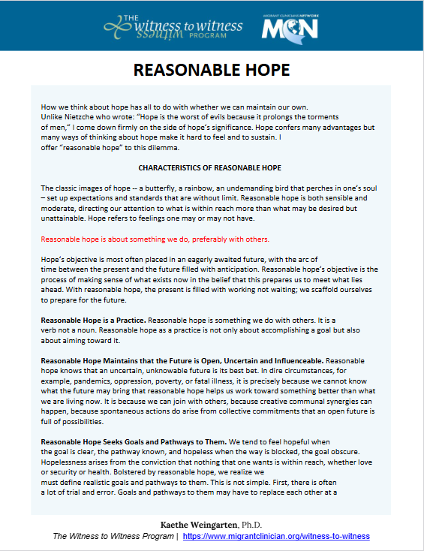 | Reasonable Hope / Esperanza Razonable  Link: https://www.migrantclinician.org/resource/reasonable-hope-w2w-resource.html

