1. **Choose five (5) possible threats that can affect the health and safety in your community. Think of the last ___ years.**

Hurricane or Earthquake Flooding Landslide Basic utilities and

Storm telecommunication failures

OTHER:

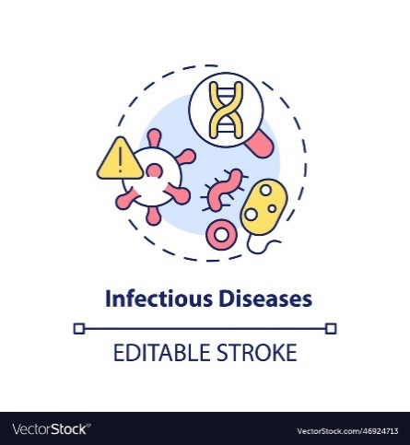 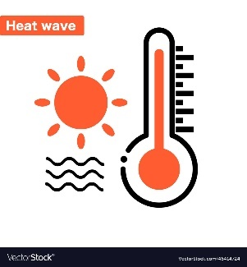  

Public Health Heat wave Drought Storm surge

Emergency (COVID, Dengue)

1. **Write the identified threats in the blank table below. Assign a color for the historical FREQUENCY of each threat and another color for the historical IMPACT in the last ___ years according to the following scales.**

|  |  |
| --- | --- |
| **FREQUENCY OF THE EVENT** | |
| **CONCEPT** | **COLOR** |
| Has happened very few times |  |
| Happens occasionally |  |
| Happens very frequently/always |  |

|  |  |
| --- | --- |
| **IMPACT OF THE EVENT** | |
| **CONCEPT** | **COLOR** |
| No people injured  No damage or losses |  |
| People suffer minor injuries  Very few damages or losses |  |
| People suffer major injuries or death  A lot of damage or destruction of property |  |

|  |  |  |
| --- | --- | --- |
| **Threat** | **COLOR ASSIGNED** | |
| **Frequency** | **Impact** |
| 1. |  |  |
| 2. |  |  |
| 3. |  |  |
| 4. |  |  |
| 5. |  |  |

1. **Evaluate and write the risk for each scenario in the table below, according to the color combination per threat.**

EXTREME RISK**: Frequency + Impact**

HIGH RISK**: Frequency + Impact OR Frequency + Impact**

MEDIUM RISK**: Frequency + Impact OR Frequency + Impact OR Frequency + Impact**

**Frequency + Impact Frequency + Impact**

LOW RISK**: Frequency + Impact**

|  |  |
| --- | --- |
| **Threat** | **Risk**  (extreme, high, medium or low) |
| 1. |  |
| 2. |  |
| 3. |  |
| 4. |  |
| 5. |  |

1. **Order the list of threats going from extreme-risk scenarios to low-risk scenarios.**

**Community Preparedness Priority List: .**

|  |  |
| --- | --- |
| **Risk**  **(in order)** | **Threat** |
|  |  |
|  |  |
|  |  |
|  |  |
|  |  |

1. **You have successfully completed an emergency risk analysis for your community!**

**Next Steps:** Farm Planning Tool,CommunitySWOT Analysis, CommunityResource Mapping and CommunityEmergency Planning