SOCIAL MEDIA TOOLKIT:
IMAGES, HASHTAGS, RESOURCE LINKS, AND DRAFT POSTS IN SPANISH WITH ENGLISH TRANSLATIONS

Hello! This document contains links to all images that can be used with campaign social media posts, hashtags, resource links, and draft posts in Spanish along with their English translations. Please click the included links to download the image files onto your computer and edit if necessary. Please feel free to use posts verbatim, to take parts of the posts, or to simply get ideas from them.
As a reminder, we ask that you post a minimum of one per day (7 posts) during this coming week. However, feel free to post much more often! We also ask that you participate in two social media storms (see campaign introduction email for more details) and share at least one video.
IMAGE BANK
Links to Download the Following Social Media Images:
About: This resource can be used as images for social media posts for any platform.
To Download: To download please click the link for the image you wish to download below. Right click image, click ‘save image as’, and save to desired folder on your computer.
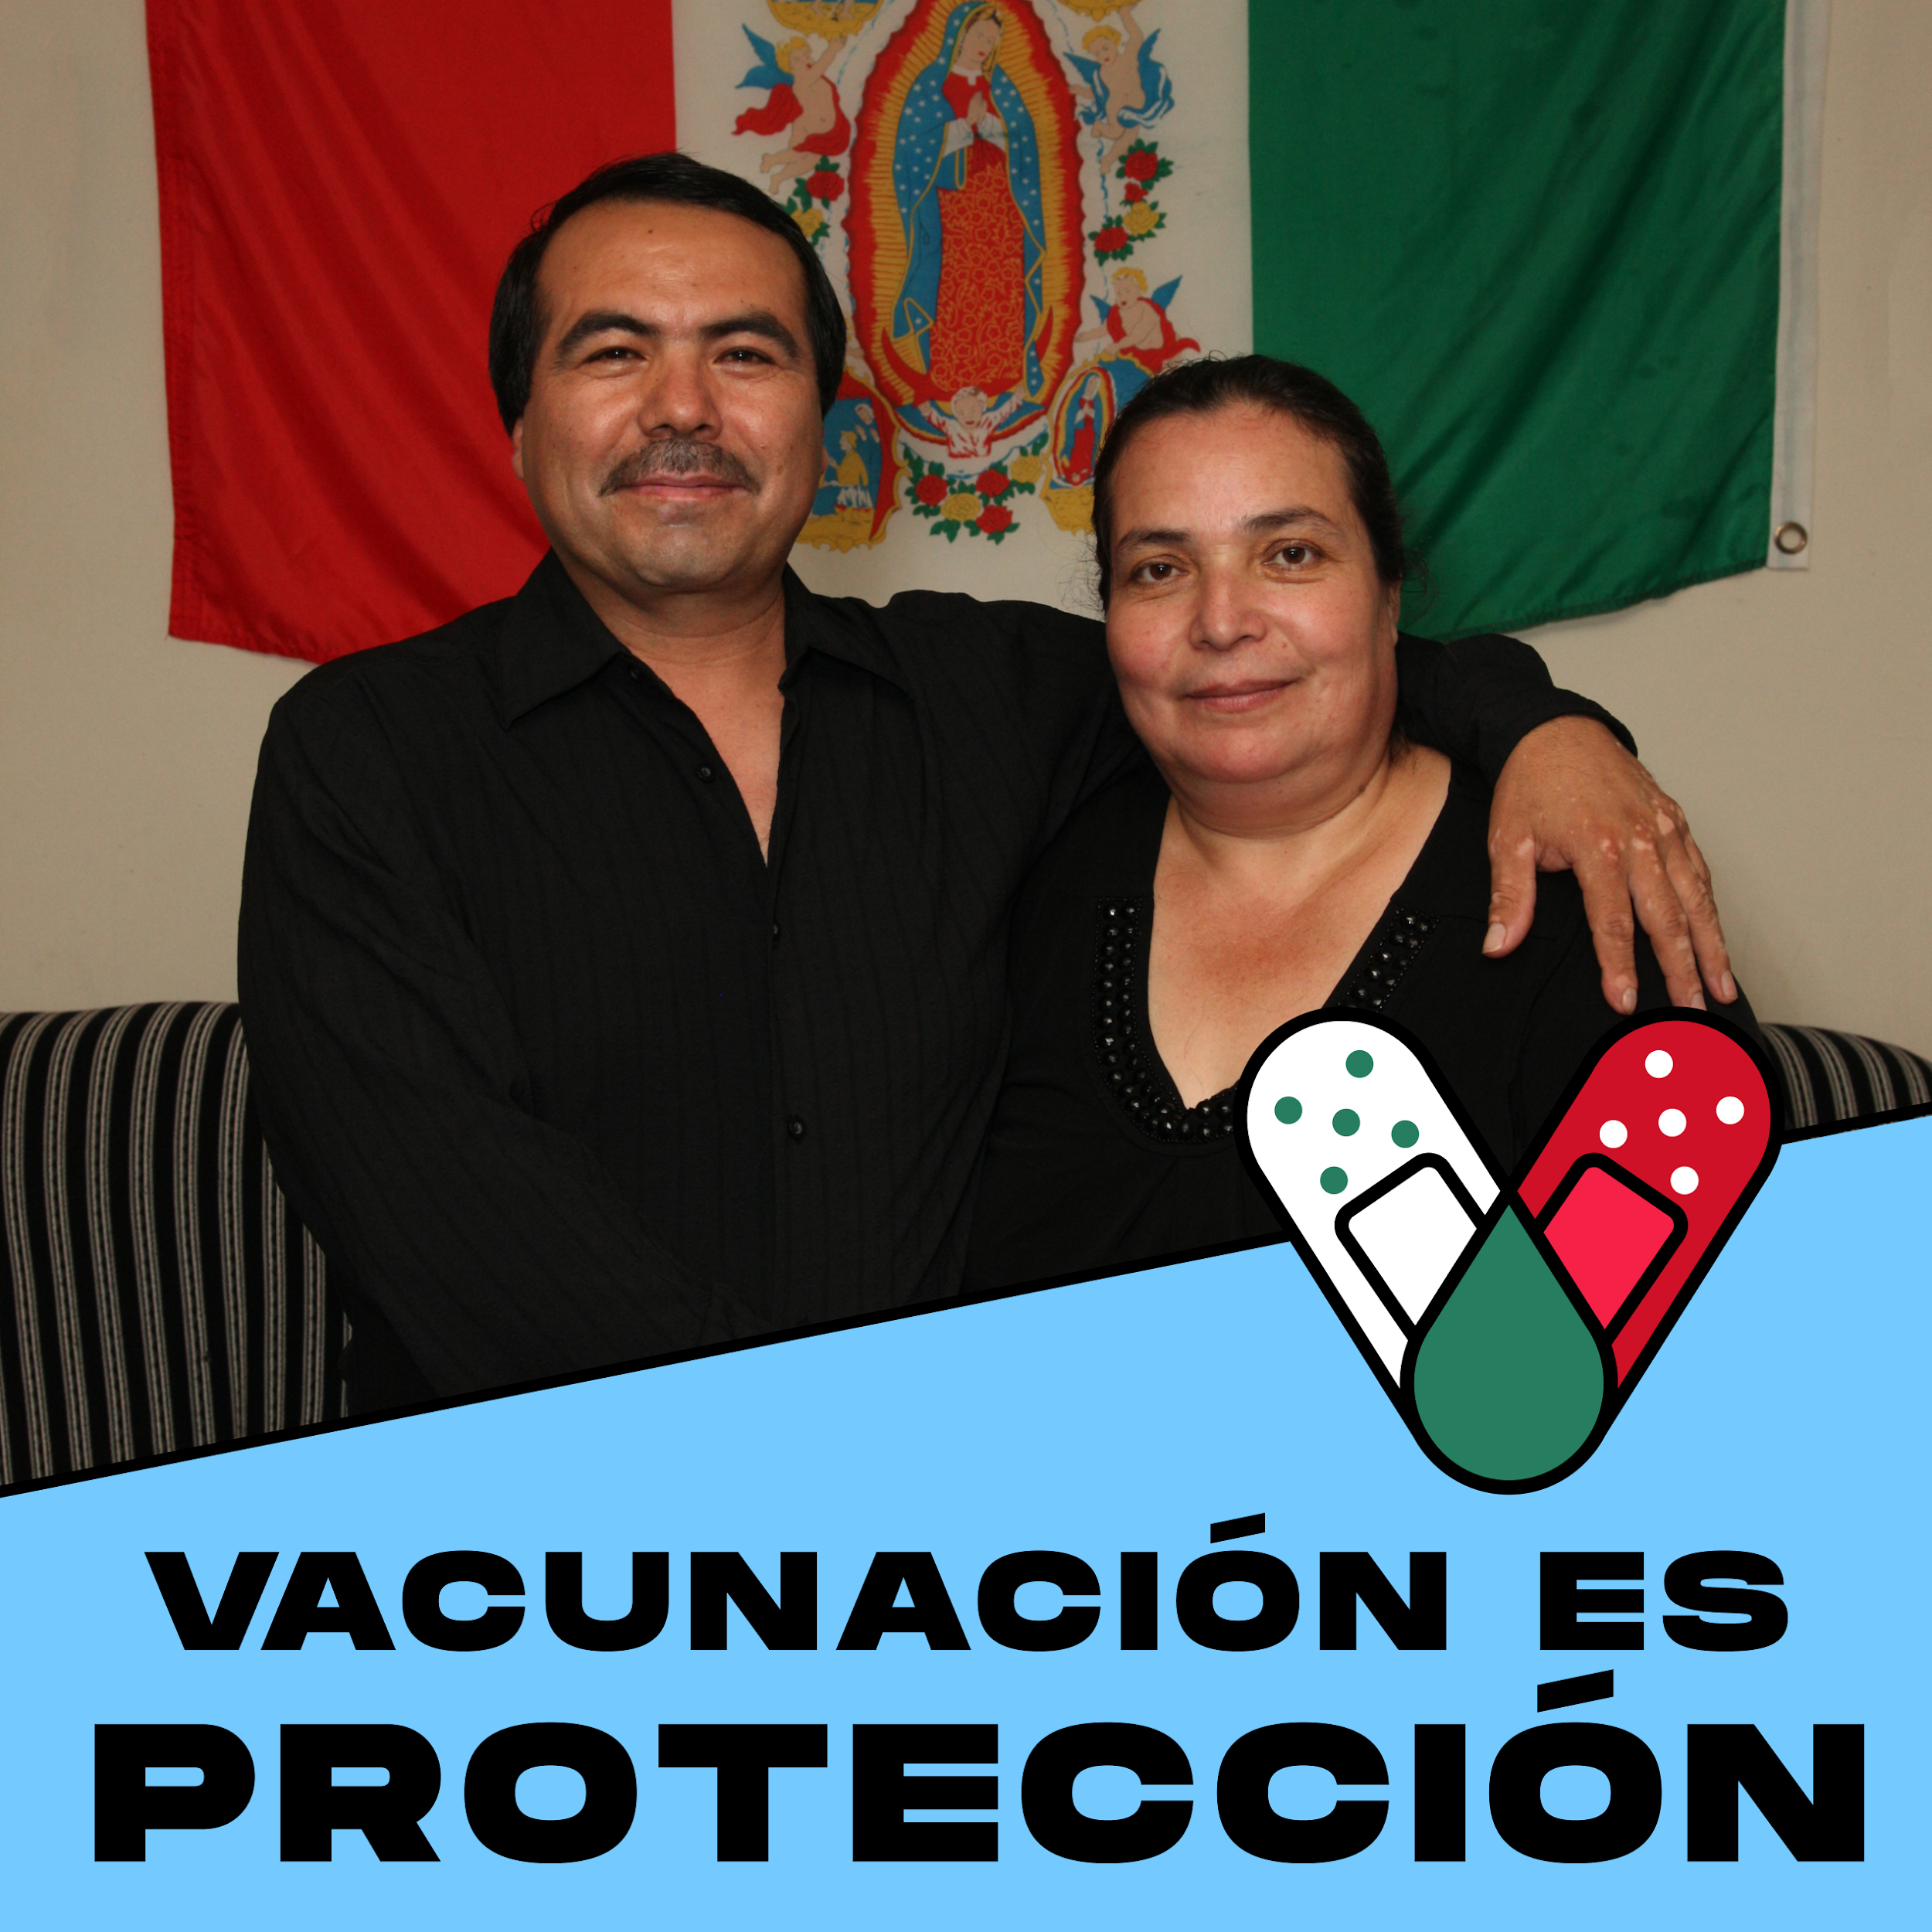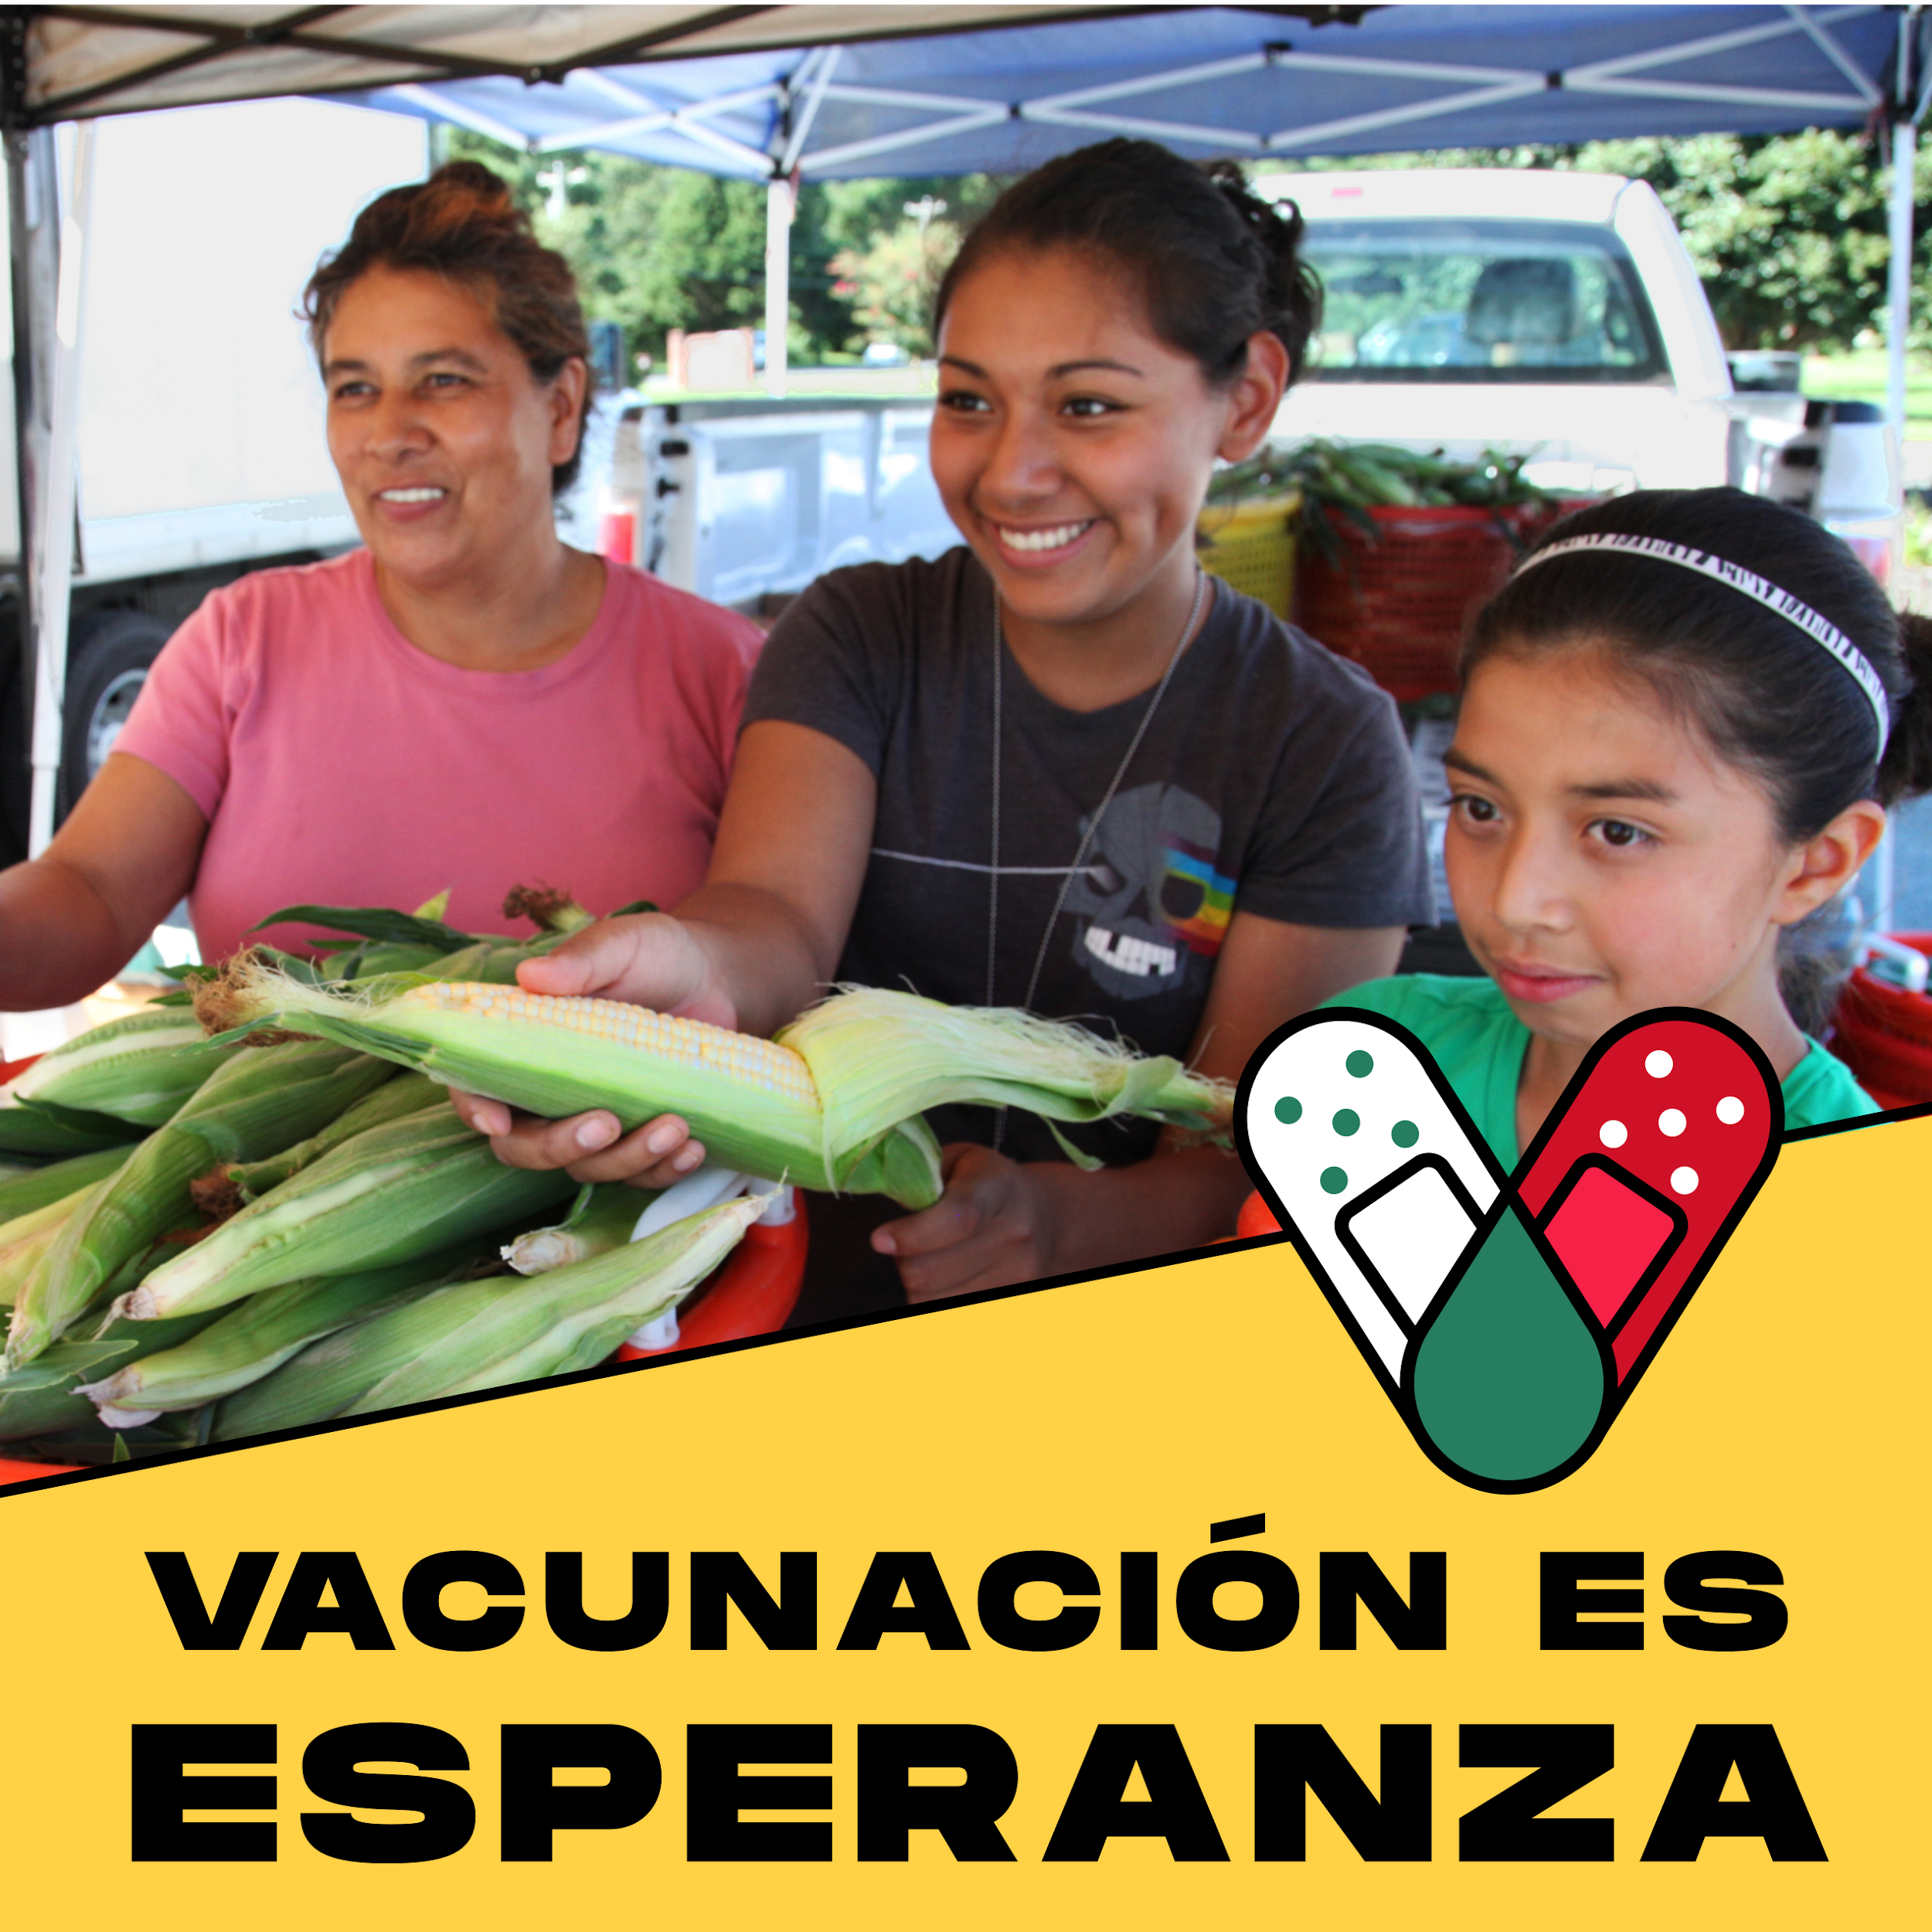

Links:
- Vacunación Es Protección
- Vacunación Es Esperanza

English Translation of Above Images and Links:
- Vaccination is Protection (Blue)
- Vaccination is Hope (Gold)

Links to Download and Edit the Following Social Media Image Frames:
About: This editable resource allows you to insert a photo of yourself, someone else, or something else in the white space behind the bottom frame/image. Download the image, and upload it as a social media profile photo for yourself or your organization, or use it as a social media post image for any platform.
To Download: To download click the download link which will contain one file for all three frames. The link will take you to the specific resource link that is also listed on MCN’s campaign page which includes some of the other campaign resources. Clicking the link will automatically download a PowerPoint file onto your computer (it will not open a new window). Please make sure your block-up protection is disabled if the file will not download. If assistance is needed, please contact your campaign contact and the file will be sent to you.
After downloading the file, you have two options to edit it. If you have PowerPoint on your computer, you will be able to edit the file in PowerPoint. If you do not have PowerPoint on your computer, you can edit this file for free by using Google Slides.
To open the document in Google Slides right clicking the document, click ‘open with’, and then click ‘Google Slides’. If this does not work for you, it may be because you do not have a Google Slides Account. If so, please sign up for Google Slides by going here and clicking ‘Go to Google Slides’. To upload the file into Google Slides click on the folder graphic (‘Open File Picker’), click ‘upload’, and upload your file.
The resource includes directions for how to save your final product as an image. If you would like assistance inserting your photo, please contact your campaign contact.
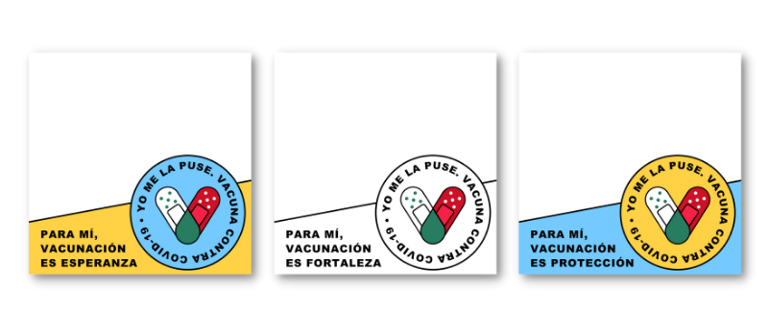
Link:
- Download link for all three resources here.
English Translation of Above Images:
- For me/To me, vaccination is protection. (Blue)
- For me/To me, vaccination is hope. (Gold)
- For me/To me, vaccination is strength. (White)

Links to Download the Following Images:
About: These resources include images that can be used for social media posting on any platform, in addition to any other purpose.
To Download: To download please click the link for the image you wish to download. The provided links follow the order of the images below (From right to left, and then top to bottom). The link will take you to the specific resource link that is also listed on MCN’s campaign page which includes some of the other campaign resources. Please right click and select ‘Save Image As’ to download to your computer. If assistance is needed, please contact your campaign contact and the file will be sent to you.
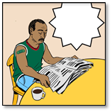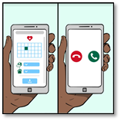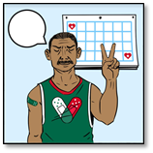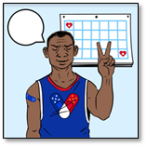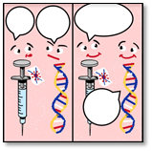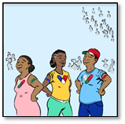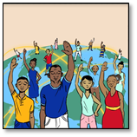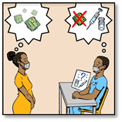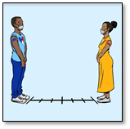
Links:
- Man In Green Shirt Sitting at Table Reading Newspaper
- Man In Blue Shirt Sitting at Table Reading Newspaper
- Phone Image Communicating Vaccine Sign-Up and Timeline of Vaccines
- Vaccinated Man In Green Shirt In Front of Calendar
- Vaccinated Man In Blue Shirt In Front of Calendar
- Vaccine and DNA
- Three Vaccinated People
- People Around the World
- Woman and Man Discussing Hesitancies and Myths
- Vaccinated Man and Woman Social Distancing and Wearing Masks

RESOURCE LINKS
Please share at least one of the following videos, or a different video that you know of and like.
- #YoMeLaPuse COVID-19 Vaccine (#IGotIt COVID-19 Vaccine) Video
- ¿Por qué se puso la vacuna? (Why Did You Get the Vaccine?) Video (Featuring Local Community Members)
- Anuncio: "La Vacuna del COVID-19: Dra. Eva Galvez, una doctora sirviendo a las comunidades migrantes e imigrantes" (PSA: "COVID-19 Vaccine: Dr. Eva Galvez, a physician serving migrant and immigrant communities") Video see English version here

HASHTAGS
We ask that you use the ‘official campaign hashtags’ in all of your social media posting if possible. Please see ‘other’ hashtags for more hashtag ideas.
Official Campaign Hashtags:
- #YoMeLaPuse (I Got It)
- #YoMeVacuno (I Get Vaccinated)

Optional Hashtags:
- #VacunaseHoy (Get Vaccinated Today - formal)
- #AltoCovid19 (Stop COVID19)
- #CubreBoca (Mask - trending hashtag)
- #YoCreoEnLaCiencia (I Believe In Science)
- #CDC

DRAFT SOCIAL MEDIA POSTS IN SPANISH WITH ENGLISH TRANSLATIONS
Below are 10 draft social media posts. Please feel free to use these posts in their entirety, to take parts of the posts, or to simply get ideas from them. The drafts include post topic, post text in Spanish, English translation of Spanish text (see note below), and a list of additional hashtags you are welcome to choose from.
Important Note: English translations for the following posts are NOT intended for social media use. While you may use them if you wish, the intent for providing these translations is for non-Spanish speakers to understand what is communicated in the Spanish posts. Differences in phrasing compared to posts intended for English-language posting may be present since direct translations are used.

DRAFT SOCIAL MEDIA POSTS IN SPANISH WITH ENGLISH TRANSLATIONS
DRAFT POST #1:

Topic: Love for Family

Post Text in Spanish: Al vacunarte proteges también a tus seres queridos contra el COVID-19. #YoMeLaPuse #YoMeVacuno #DelmarvaVacunada

Translation in English: By getting vaccinated, you also protect your loved ones from COVID-19. #IGotIt #IGetVaccinated #DelmarvaIsVaccinated

Optional Additional Hashtags: #VacunaseHoy (get vaccinated today - formal); #AltoCovid19 (Stop COVID19); #CubreBoca (Mask); #CDC #Yocreenlaciencia (I Believe in Science)
DRAFT POST #2:

Topic: Love for Community

Post Text in Spanish: En nuestra comunidad nos cuidamos unos a otros. Haz la diferencia. Vacúnate contra el COVID-19. #YoMeLaPuse #YoMeVacuno #DelmarvaVacunada

Translation in English: In our community, we take care of each other. Make a difference. Get vaccinated against COVID-19. #IGotIt #IGetVaccinated #DelmarvaIsVaccinated

Optional Additional Hashtags: #VacunaseHoy (get vaccinated today - formal); #AltoCovid19 (Stop COVID19); #CubreBoca (Mask); #CDC #Yocreenlaciencia (I Believe in Science)
DRAFT POST #3:

Topic: Strength In Unity

Post Text in Spanish: La unión hace la fuerza. Con cada persona que se vacuna nuestra comunidad se hace más fuerte y el virus se hace más débil. #YoMeLaPuse #YoMeVacuno #DelmarvaVacunada

Translation in English: United we are strong. The union makes the force. With each person that gets vaccinated, our community becomes stronger and the virus becomes weaker. #IGotIt #IGetVaccinated #DelmarvaIsVaccinated

Optional Additional Hashtags: #VacunaseHoy (get vaccinated today - formal); #AltoCovid19 (Stop COVID19); #CubreBoca (Mask); #CDC #Yocreenlaciencia (I Believe in Science)
DRAFT POST #4:

Topic: Fight COVID Together

Post Text in Spanish: Una comunidad unida es una comunidad fuerte. Vacunémonos para vencer juntos al COVID-19. #YoMeLaPuse #YoMeVacuno #DelmarvaVacunada

Translation in English: A united community is a strong community. Let's get vaccinated to defeat COVID-19 together. #IGotIt #IGetVaccinated #DelmarvaIsVaccinated

Optional Additional Hashtags: #VacunaseHoy (get vaccinated today - formal); #AltoCovid19 (Stop COVID19); #CubreBoca (Mask); #CDC #Yocreenlaciencia (I Believe in Science)
DRAFT POST #5:

Topic: Community Unity

Post Text in Spanish: Con cada persona vacunada, renovamos nuestra esperanza de volver a reunirnos como comunidad. #YoMeLaPuse #YoMeVacuno #DelmarvaVacunada

Translation in English: With each person vaccinated, we renew our hope of reuniting as a community. #IGotIt #IGetVaccinated #DelmarvaIsVaccinated

Optional Additional Hashtags: #VacunaseHoy (get vaccinated today - formal); #AltoCovid19 (Stop COVID19); #CubreBoca (Mask); #CDC #Yocreenlaciencia (I Believe in Science)
DRAFT POST #6:

Topic: Future Possibilities

Post Text in Spanish: Las bodas, los juegos deportivos e ir a bailar serán posibles cuando todos nos vacunemos contra el COVID-19. #YoMeLaPuse #YoMeVacuno #DelmarvaVacunada

Translation in English: Weddings, sports games, and dancing will be possible when we are all vaccinated against COVID-19. #IGotIt #IGetVaccinated #DelmarvaIsVaccinated

Optional Additional Hashtags: #VacunaseHoy (get vaccinated today - formal); #AltoCovid19 (Stop COVID19); #CubreBoca (Mask); #CDC #Yocreenlaciencia (I Believe in Science)
DRAFT POST #7:

Topic: No Cost

Post Text in Spanish: El costo para su seguridad contra el COVID-19 le cuesta nada, vacunase hoy! #YoMelaPuse #YoMeVacuno #DelmarvaVacunada

Translation in English: The cost for your safety against COVID-19 is nothing, get vaccinated today! #IGotIt #IGetVaccinated #DelmarvaIsVaccinated

Optional Additional Hashtags: #VacunaseHoy (get vaccinated today - formal); #AltoCovid19 (Stop COVID19); #CubreBoca (Mask); #CDC #Yocreenlaciencia (I Believe in Science)
DRAFT POST #8:

Topic: Social Distance and wear mask even after being vaccinated

Post Text in Spanish: Juntos en la lucha hasta el final! Hasta que no estemos vacunados es importante continuar usando nuestras mascarillas. #YoMelaPuse #YoMeVacuno #DelmarvaVacunada

Translation in English: We are in this together until the end. Until we are not all vaccinated, it is important to continue wearing your masks. #IGotIt #IGetVaccinated #DelmarvaIsVaccinated

Optional Additional Hashtags: #VacunaseHoy (get vaccinated today - formal); #AltoCovid19 (Stop COVID19); #CubreBoca (Mask); #CDC #Yocreenlaciencia (I Believe in Science)
DRAFT POST #9:

Topic: Some vaccines require one dose, some require two doses

Post Text in Spanish: ¡Conoce tu vacuna contra el COVID-19! Las vacunas que requieren dos dosis son las de Pfizer y Moderna. La vacuna de Johnson & Johnson solo requiere una dosis! #YoMelaPuse #YoMeVacuno #DelmarvaVacunada

Translation in English: Know your COVID-19 vaccine! The vaccines that need two doses are from Pfizer and Moderna. The vaccine from Johnson & Johnson needs only one dosis! #IGotIt #IGetVaccinated #DelmarvaIsVaccinated

Optional Additional Hashtags: #VacunaseHoy (get vaccinated today - formal); #AltoCovid19 (Stop COVID19); #CubreBoca (Mask); #CDC #Yocreenlaciencia (I Believe in Science)
DRAFT POST #10:

Topic: Limited side effects

Post Text in Spanish: ¡No se preocupe! Los efectos secundarios sólo pueden ser dolor de brazo, dolor de cabeza, fiebre o escalofríos. #YoMelaPuse #YoMeVacuno #DelmarvaVacunada

Translation in English: Don’t worry! The side effects may only be arm soreness, headache, fever, or chills. #IGotIt #IGetVaccinated #DelmarvaIsVaccinated

Optional Additional Hashtags: #VacunaseHoy (get vaccinated today - formal); #AltoCovid19 (Stop COVID19); #CubreBoca (Mask); #CDC #Yocreenlaciencia (I Believe in Science)

