MATERYÈL POU KANPAY REZO SOSIO AN:
IMAJ, HASHTAGS, VIDEYO, AK BOUYON/EGZANP POU POST AN KREYOL AK TRADIKSYON AN ANGLE

Alo!
Dokiman sa a gen lyen ki ap mennen w pou jwen tout imaj ou ka itilize ak posté pou kanpay lan. Li gen hashtags, videyo, ak egzanp de pos ou ka posté an Kreyòl e kisa yo vlé di an Anglè. Tanpri kliké sou lyen nou ba ou yo, pou ou ka download imaj yo sou òdinatè ou epi modifye si sa nesesè. Si ou vlé ou ka menm itilizé egzanp nou bay yo epi posté li, pou w patisipé nan kanpay la. Oswa tou senpman, nou ba ou on idé de kisa ou ka posté.
Nap fè w sonje, nou mande w posté yon minimòm de yon pos pa jou (7 pos) pandan semèn nan. Sepandan, ou ka posté pi souvan, si ou vlé! Nap tou mande w, si ou ka patisipé nan posté an menm tan ak tout moun (Wap jwen enfomasyon nan premye e-mail nou voyé pou kanpay la. Wap jwen plis detay), ak patajé omwen yon videyo.

IMAJ BANK
Lyen pou download imaj pou posté sou rezo sosio:
Enfòmasyon: Resous sa yo, ou ka itilize kòm imaj pou pos sou rezo sosio pou nenpòt platfòm.
Pou Download: Pou download, tanpri kliké sou lyen imaj ou ta vlé download anba a. Kliké sou imaj, kliké sou 'save image as’, epi li rete sou òdinatè ou an pou ka itilizé .

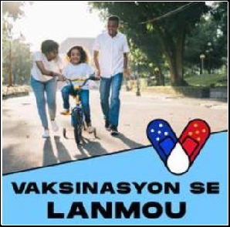
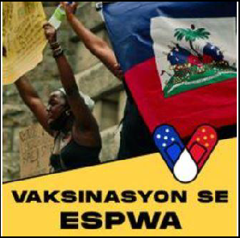
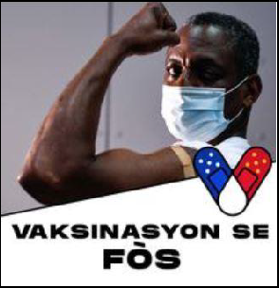

Lyens:
- Vaksinasyon Se Lanmou
- Vaksinasyon Se Espwa
- Vaksinasyon Se Fòs

Tradiksyon an Angle pou imaj anwo yo avek lyens pou yo:
- Vaccination is Love (Blue)
- Vaccination is Hope (Gold)
- Vaccination is Strength (White)

Lyens pou download epi modifye imaj pou poste sou rezo sosio:
Enfòmasyon: Resous editabl sa a pèmèt ou mete yon foto tèt ou, yon lòt moun, oswa yon lòt bagay nan espas blan an dèyè ankadreman/imaj anba an. Download imaj la, epi mete li kòm foto pwofil ou sou rezo sosio ou oswa òganizasyon ou an. Ou ka itilizé li kòm yon imaj pwofil pou nenpòt ki platfòm ou vle.

Pou Download: Pou download, kliké sou lyen an epi lap gen yon sèl dosye pou tout lè twa ankadreman yo. Lyen an ap mennen w nan sou menm lyen resous espesifik ki sou sit MCN nan pou kanpay la. Sou sit MCN nan, wap jwen lòt resous kanpay yo. Si ou Kliké sou lyen an, otomatikman lap download yon dosye PowerPoint sou òdinatè w lan. Si ou bezwen asistans, tanpri kontakte Habacuc Petion epi li pral voye dosye a ba ou dirèkteman.
Aprè ou fin download dosye a, ou gen de opsyon pou edite li. Si ou gen PowerPoint sou òdinatè w lan, ou ka modifye dosye a nan pwogram PowerPoint lan. Si ou pa gen PowerPoint sou òdinatè w lan, ou ka edite dosye sa a gratis lè ou itilize Google Slides nan G-mail.
Pou w ouvri dokiman an nan Google Slides, ou ta dwe kliké sou dokiman an, kliké sou 'open with', epi Lè sa a kliké sou 'Google Slides'. Si sa pa maché pou ou, se gendwa paske ou pa gen yon kont Google Slides. Si ou pa gen on kont, tanpri enskri pou Google Slides la epi kliké sou 'Go to Google Slides'. Pou download dosye a nan Google Slides kliké sou grafik katab la ('Open File Picker'), kliké sou 'upload', epi download dosye ou.
Resous la gen direksyon pou kòman pou w konsève pwodwi final ou a kòm yon imaj. Si ou ta renmen asistans pou mete foto ou, tanpri kontakte Habacuc Petion.
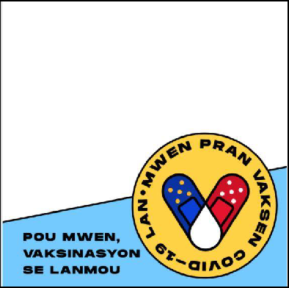
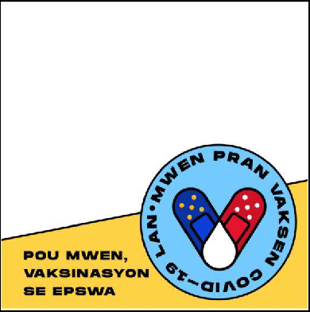
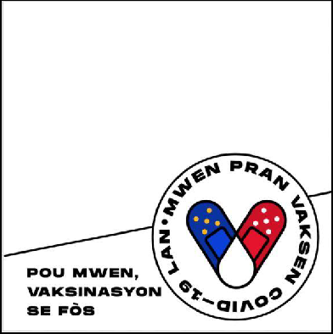
Lyen:
- Lyen pou download tout lè twa resous yo
Tradiksyon an Anglè pou imaj anwo yo
- For me, vaccination is love. (Blue)
- For me, vaccination is hope. (Gold)
- For me, vaccination is strength. (White)

Link pou download imaj sa yo:
Enfòmasyon: Resous sa yo, gen nan imaj yo ou ka itilize sou rezo sosio pou poste sou nenpòt ki platfòm epi pou nenpòt lòt objektif.
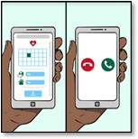
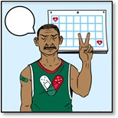
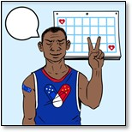
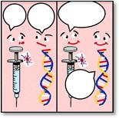
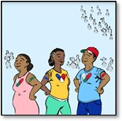
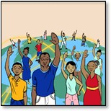
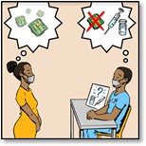
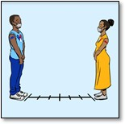
Pou Download: Pou download, tanpri kliké sou lyen pou imaj la ou ta vle an. Lyen nou bay yo swiv lòd imaj yo ye anba a ( Dwat a goch, epi anwo rivé anba). Lyen an ap mennen w nan lyen resous espesifik ki tou nan lis sou paj kanpay MCN an. La, wap jwen lòt resous kanpay yo. Tanpri kliké sou imaj ou vle an epi chwazi 'Save Image As' pou w download sou òdinatè w lan. Si ou bezwen asistans, tanpri kontakte Habacuc Petion epi lap voye dosye a ba ou.

Lyen:
- Gason nan chemiz vèt ki chita sou tab la kap li jounal nan
- Gason nan chemiz ble ki chita sou tab la ki ap li jounal nan
- Imaj Telefòn Ki ap Kominike Pou Enskri pou pran Vaksen an
- Misye an ki Vaksinen an nan chemiz vèt devan kalandriye
- Misye an ki Vaksinen an nan chemiz ble devan kalandriye
- Vaksen ak ADN
- Twa moun ki pran vaksen an
- Moun ki nan diferan kote nan mond la
- Fi an ak gason an ki ap diskite ezitasyon ak mit
- Misye an ki Vaksinen an ak Fi ki ap pran distans Sosyal epi ki Mete mask

VIDEYO
Tanpri pataje omwen youn nan videyo sa yo, paj resous sit Rebirth lan (kote telespektatè yo ka jwenn videyo sou COVID-19 ak vaksen an kreyòl), oswa yon videyo diferan ke ou konnen epi pou renmen sou sijè sa.
- (En Kreyòl) Ou Ta Dwe Pran Vaksen COVID-19 La
- Paj Rebirth lan ki gen Resous pou Kominote sou COVID-19

HASHTAGS
Nou mande w pou itilizé 'ofisyèl hashtags kanpay la’ nan tout pos ou fè sou rezo sosio ou, si sa posib. Tanpri gade ‘lòt’ hashtags pou plis egzanp ou ka itilizé pou hashtag yo.

Ofisyèl hashtags kanpay la:
- #MwenPranL (I took it)
- #MwenPranVaksenAn (I get vaccinated)
- #DelmarvaPranVaksenAn (Delmarva is vaccinated)
- #SanteLakay (home-based health/community health)

Lòt Egzanp:
- #VaksinenJodiA (Get Vaccinated Today)
- #KanpeCOVID19 (Stop COVID-19)
- #Mask
- #MwenKweNanLaSyans (I believe in Science)
- #CDC

PWOJE POS REZO SOSIO EN KREYOL AK TRADIKSYON EN ANGLE
Anba a, wap jwen 15 pòs bouyou/egzanp ou ka itilizé sou rezo sosio. Ou mèt itilizé egzanp yo egzakteman jan yo ye an pou w patisipé nan kanpay la oswa tou senpleman jwen on idé de kisa ou ka posté. Egzanp yo gen sijè pou pòs yo, tèks afiche en kreyòl, tradiksyon en Anglè pou pòs yo, ak yon lis hashtags adisyonèl ou ka chwazi pou w itilizé.
Nòt Enpòtan: Tradiksyon en Anglè pou pòs yo PA fèt pou itilizasyon sou rezo sosio medya. Ou ka itilize yo si ou vle, entansyon an se pou bay tradiksyon. Se plis pou moun ki pa pale kreyòl yo, pou yo ka konprann sa nou ap kominike nan pòs yo en kreyòl.

PWOJE POS REZO SOSIO EN KREYOL AK TRADIKSYON EN ANGLE
DRAFT POST #1:

Topic: Love

Haitian Creole: Nou pran vaksen pou COVID-19 la pou pwoteje fanmi nou epi pou kenbe moun nou renmen yo ansekirite. #MwenPranL #MwenPranVaksenAn #DelmarvaPranVaksenAn #SanteLakay

Translation In English: We vaccinate to protect our family and keep our loved ones safe. #ITookIt #IGetVaccinated #DelmarvaIsVaccinated #Home-based health/community health

Other Additional Hashtags in Haitian Creole: #VaksinenJodiA (Get Vaccinated Today), #KanpeCOVID19 (Stop COVID-19), #Mask, #MwenKweNanLaSyans (I believe in Science), #CDC
DRAFT POST #2:

Topic: Love

Haitian Creole: Renmen vwazen ou menjan ou renmen tèt ou. Pran vaksen kont COVID-19 la. #MwenPranL #MwenPranVaksenAn #DelmarvaPranVaksenAn #SanteLakay

Translation In English: Love your neighbor as yourself. Vaccinate against COVID-19. #ITookIt #IGetVaccinated #DelmarvaIsVaccinated #Home-based health/community health

Other Additional Hashtags in Haitian Creole: #VaksinenJodiA (Get Vaccinated Today), #KanpeCOVID19 (Stop COVID-19), #Mask, #MwenKweNanLaSyans (I believe in Science), #CDC
DRAFT POST #3:

Topic: Strength

Haitian Creole: L’union fait la force/Ansanm nou fò. Ak chak moun ki pran vaksen an, kominote nou an pran fòs epi viris la vin pi fèb. #MwenPranL #MwenPranVaksenAn #DelmarvaPranVaksenAn #SanteLakay

Translation in English: L’union fait la force. With every person vaccinated, our community gets stronger and the virus gets weaker. #ITookIt #IGetVaccinated #DelmarvaIsVaccinated #Home-based health/community health

Other Additional Hashtags in Haitian Creole: #VaksinenJodiA (Get Vaccinated Today), #KanpeCOVID19 (Stop COVID-19), #Mask, #MwenKweNanLaSyans (I believe in Science), #CDC
DRAFT POST #4:

Topic: Love for Family

Post in Haitian Creole: Lè w pran vaksen, ou pwoteje moun ou renmen yo tou kont COVID-19. #MwenPranL #MwenPranVaksenAn #DelmarvaPranVaksenAn #SanteLakay

Translation in English: By getting vaccinated, you also protect your loved ones from COVID-19. #ITookIt #IGetVaccinated #DelmarvaIsVaccinated #Home-based health/community health

Other Additional Hashtags in Haitian Creole: #VaksinenJodiA (Get Vaccinated Today), #KanpeCOVID19 (Stop COVID-19), #Mask, #MwenKweNanLaSyans (I believe in Science), #CDC
DRAFT POST #5:

Topic: Love for Community

Post in Haitian Creole: Nan kominote nou, nou pran swen youn lòt. Fè yon diferans. Pran vaksen kont COVID-19 la. #MwenPranL #MwenPranVaksenAn #DelmarvaPranVaksenAn #SanteLakay

Translation in English: In our community, we take care of each other. Make a difference. Get vaccinated against COVID-19. #ITookIt #IGetVaccinated #DelmarvaIsVaccinated #Home-based health/community health

Other Additional Hashtags in Haitian Creole: #VaksinenJodiA (Get Vaccinated Today), #KanpeCOVID19 (Stop COVID-19), #Mask, #MwenKweNanLaSyans (I believe in Science), #CDC
DRAFT POST #6:

Topic: Fight COVID Together

Post in Haitian Creole: Yon kominote ki gen tèt ansanm se yon kominote ki gen fòs. Annou pran vaksen pou nou venk COVID-19 ansanm. #MwenPranL #MwenPranVaksenAn #DelmarvaPranVaksenAn #SanteLakay

Translation in English: A united community is a strong community. Let's get vaccinated to defeat COVID-19 together. #ITookIt #IGetVaccinated #DelmarvaIsVaccinated #Home-based
health/community health

Other Additional Hashtags in Haitian Creole: #VaksinenJodiA (Get Vaccinated Today), #KanpeCOVID19 (Stop COVID-19), #Mask, #MwenKweNanLaSyans (I believe in Science), #CDC
DRAFT POST #7:

Topic: Community Unity

Post in Haitian Creole: Ak chak moun ki pran vaksen an, nou renouvle espwa nou pou nou ka reyini ankò antanke yon kominote. #MwenPranL #MwenPranVaksenAn #DelmarvaPranVaksenAn #SanteLakay

Translation in English: With each person vaccinated, we renew our hope of reuniting as a community. #ITookIt #IGetVaccinated #DelmarvaIsVaccinated #Home-based health/community health

Other Additional Hashtags in Haitian Creole: #VaksinenJodiA (Get Vaccinated Today), #KanpeCOVID19 (Stop COVID-19), #Mask, #MwenKweNanLaSyans (I believe in Science), #CDC
DRAFT POST #8:

Topic: Future Possibilities

Post in Haitian Creole: Maryaj, jwèt spò ak danse pral posib lè nou tout fin pran vaksen kont COVID-19 la. #MwenPranL #MwenPranVaksenAn #DelmarvaPranVaksenAn #SanteLakay

Translation in English: Weddings, sports games, and dancing will be possible when we are all vaccinated against COVID-19. #ITookIt #IGetVaccinated #DelmarvaIsVaccinated #Home-based health/community health

Other Additional Hashtags in Haitian Creole: #VaksinenJodiA (Get Vaccinated Today), #KanpeCOVID19 (Stop COVID-19), #Mask, #MwenKweNanLaSyans (I believe in Science), #CDC
DRAFT POST #9:

Topic: No Cost

Post in Haitian Creole: Li pa koute anyen pou ou pwoteje kont COVID-19 la. Pran vaksen jodia! #MwenPranL #MwenPranVaksenAn #DelmarvaPranVaksenAn #SanteLakay

Translation in English: The cost for your safety against COVID-19 is nothing, get vaccinated today! #ITookIt #IGetVaccinated #DelmarvaIsVaccinated #Home-based health/community health

Other Additional Hashtags in Haitian Creole: #VaksinenJodiA (Get Vaccinated Today), #KanpeCOVID19 (Stop COVID-19), #Mask, #MwenKweNanLaSyans (I believe in Science), #CDC
DRAFT POST #10:

Topic: Social Distance and wear mask even after being vaccinated

Post in Haitian Creole: Nou la ansanm jiska lafen. Toutotan nou tout poko pran vaksen an, li enpòtan pou w kontinye mete mask ou. #MwenPranL #MwenPranVaksenAn #DelmarvaPranVaksenAn #SanteLakay

Translation in English: We are in this together until the end. Until we are not all vaccinated, it is important to continue wearing your masks. #ITookIt #IGetVaccinated #DelmarvaIsVaccinated #Home-based health/community health

Other Additional Hashtags in Haitian Creole: #VaksinenJodiA (Get Vaccinated Today), #KanpeCOVID19 (Stop COVID-19), #Mask, #MwenKweNanLaSyans (I believe in Science), #CDC
DRAFT POST #11:

Topic: Some vaccines require one dose, some require two doses

Post in Haitian Creole: Konnen vaksen kont COVID-19 la yo! Vaksen ki mande de doz yo soti nan Pfizer (Fayzè) ak Moderna. Vaksen ki soti nan Johnson & Johnson la mande yon sèl doz. #MwenPranL
#MwenPranVaksenAn #DelmarvaPranVaksenAn #SanteLakay

Translation in English: Know your COVID-19 vaccine! The vaccines that need two doses are from Pfizer and Moderna. The vaccine from Johnson & Johnson needs only one dose! #ITookIt #IGetVaccinated #DelmarvaIsVaccinated #Home-based health/community health

Other Additional Hashtags in Haitian Creole: #VaksinenJodiA (Get Vaccinated Today), #KanpeCOVID19 (Stop COVID-19), #Mask, #MwenKweNanLaSyans (I believe in Science), #CDC
DRAFT POST #12:

Topic: Limited side effects

Post in Haitian Creole: Pa enkyete w! Sèl efè segondè li bay yo se doulè nan bra, tèt fè mal, lafyèv oswa frison. #MwenPranL #MwenPranVaksenAn #DelmarvaPranVaksenAn #SanteLakay

Translation in English: Don’t worry! The side effects may only be arm soreness, headache, fever, or chills. #ITookIt #IGetVaccinated #DelmarvaIsVaccinated #Home-based health/community health

Other Additional Hashtags in Haitian Creole: #VaksinenJodiA (Get Vaccinated Today), #KanpeCOVID19 (Stop COVID-19), #Mask, #MwenKweNanLaSyans (I believe in Science), #CDC
DRAFT POST #13:

Topic: Community

Post in Haitian Creole: Vaksen an ka fè nou sivilizé ankò. #MwenPranL #MwenPranVaksenAn
#DelmarvaPranVaksenAn #SanteLakay

Translation in English: Vaccination can make us civil again. #ITookIt #IGetVaccinated #DelmarvaIsVaccinated #Home-based health/community health

Other Additional Hashtags in Haitian Creole: #VaksinenJodiA (Get Vaccinated Today), #KanpeCOVID19 (Stop COVID-19), #Mask, #MwenKweNanLaSyans (I believe in Science), #CDC
DRAFT POST #14:

Topic: Health

Post in Haitian Creole: Nou vaksinen pou nou rete en sante.

Translation in English: We vaccinate to keep us healthy.

Other Additional Hashtags in Haitian Creole: #VaksinenJodiA (Get Vaccinated Today), #KanpeCOVID19 (Stop COVID-19), #Mask, #MwenKweNanLaSyans (I believe in Science), #CDC
DRAFT POST #15:

Topic: Survival

Post in Haitian Creole: Vaksinen pou nou ka sove.

Translation in English: Vaccinate for our survival.

Other Additional Hashtags in Haitian Creole: #VaksinenJodiA (Get Vaccinated Today), #KanpeCOVID19 (Stop COVID-19), #Mask, #MwenKweNanLaSyans (I believe in Science), #CDC

